

**A- System User Manual.**

**B- Project Summary.**

**C- installation manual.**

|  |
| --- |
| Project : Recruitment Solution Agency( RSA) |
| **Yazan Mohammad Amin**   |  |  |  | | --- | --- | --- | | NAME | CONTACT NO | EMAIL | | Yazan Mohammad Amin | 0790939430 | [yznbrhm77@gmail.com](mailto:yznbrhm77@gmail.com) | |

**A. System User Manual:**

The System User Manual is a comprehensive document designed to assist users in understanding and effectively using the Recruitment Solution System. It includes detailed, step-by-step instructions on how to navigate the system's features. To enhance clarity, this manual may incorporate screenshots or diagrams, ensuring that users can easily follow procedures. It covers everything from user registration to job posting, applicant management, and reporting functions. This manual serves as an essential resource for both new and experienced users, empowering them to make the most of the system's capabilities.

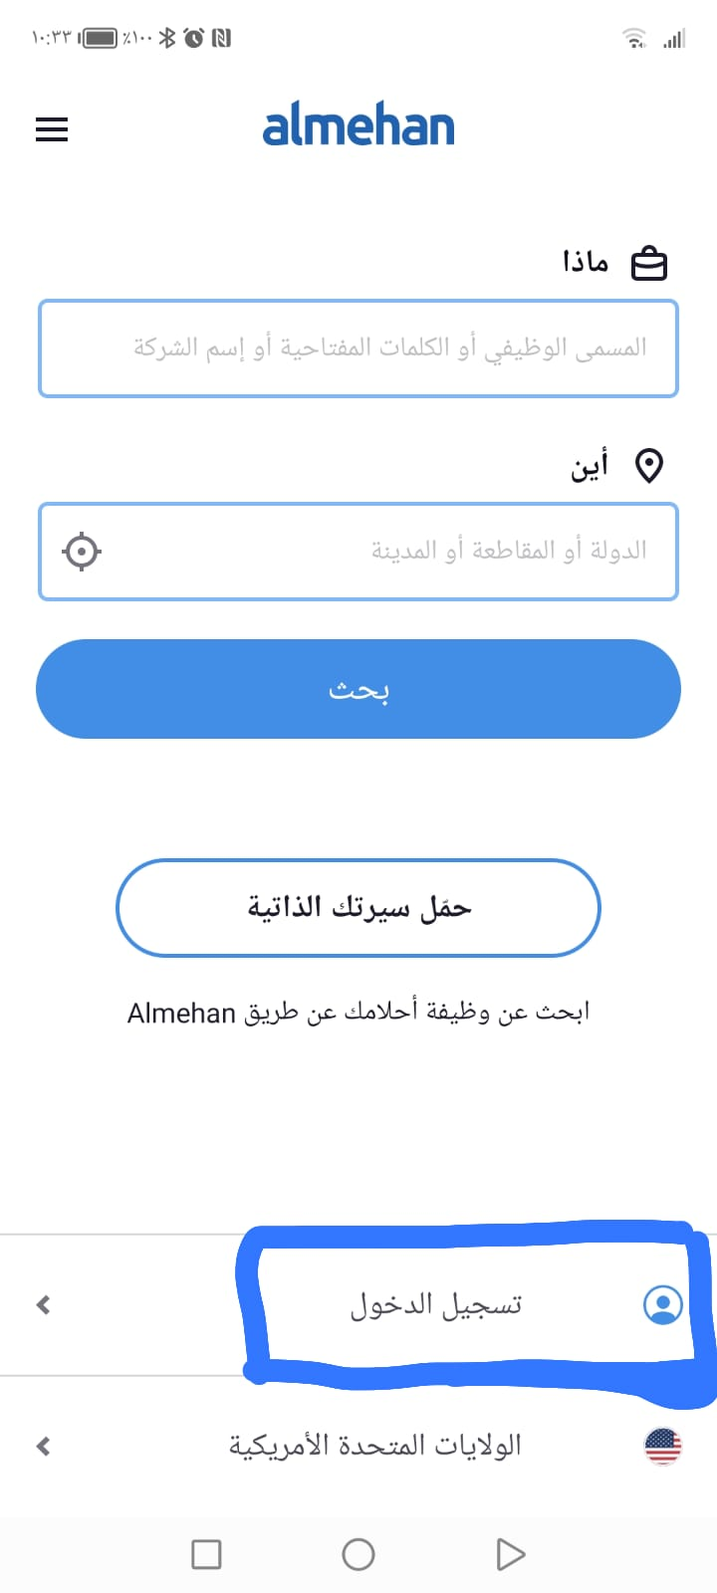

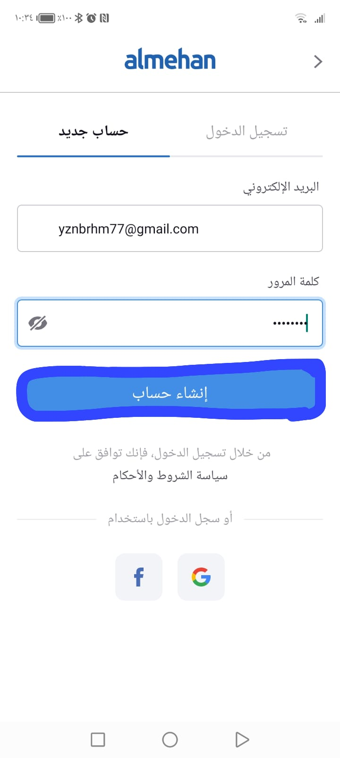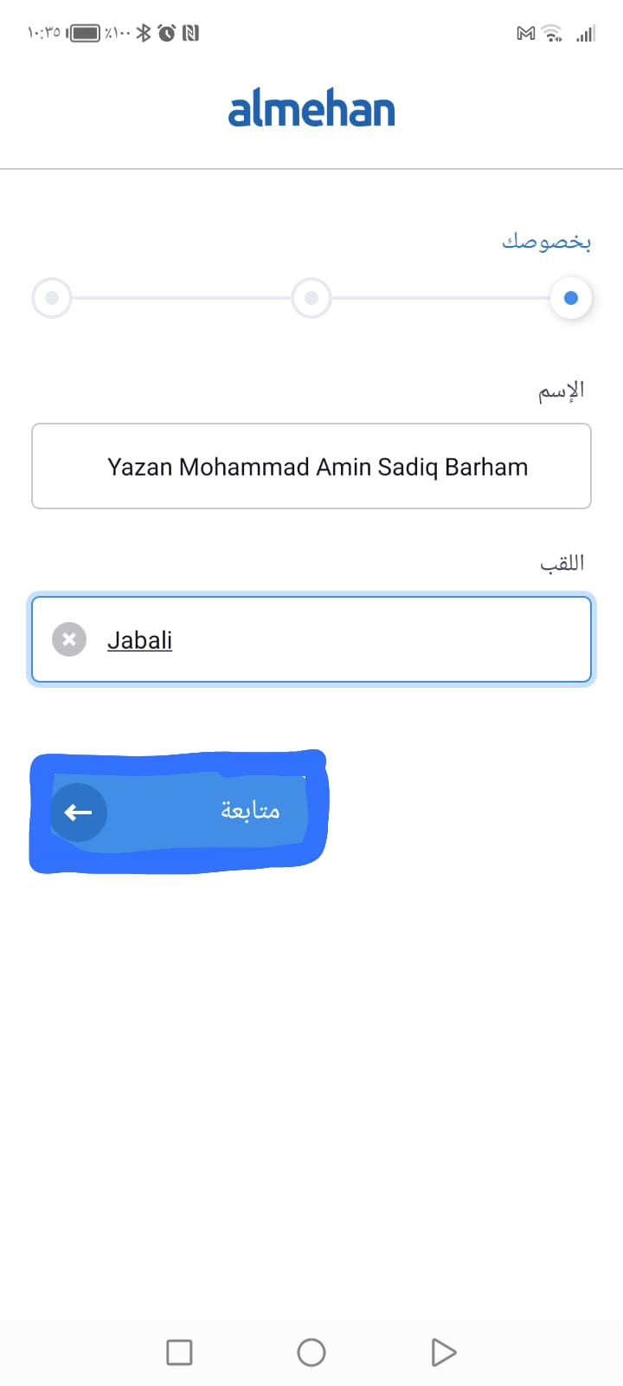

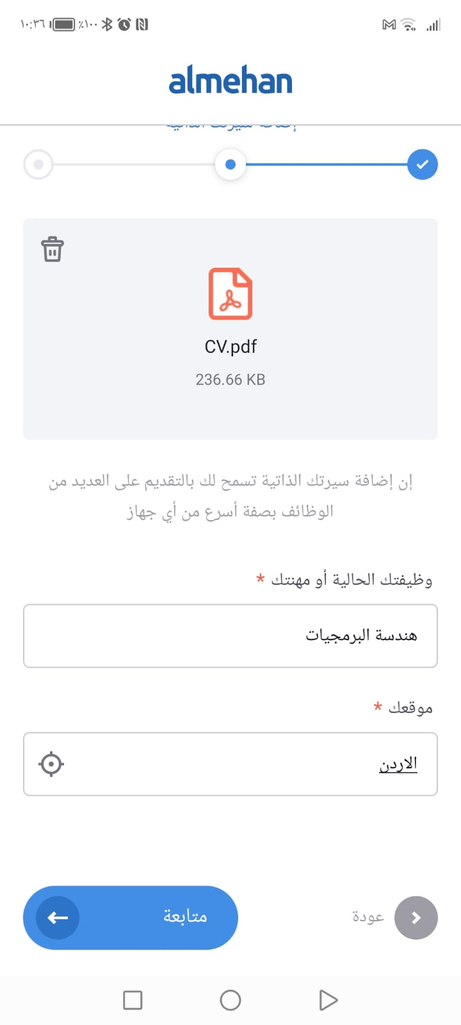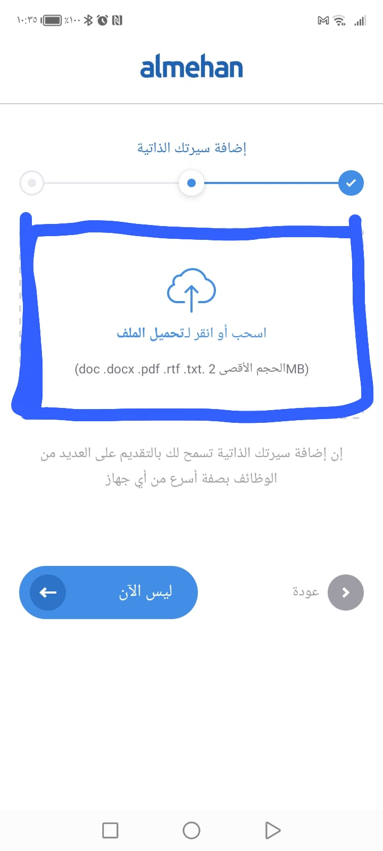

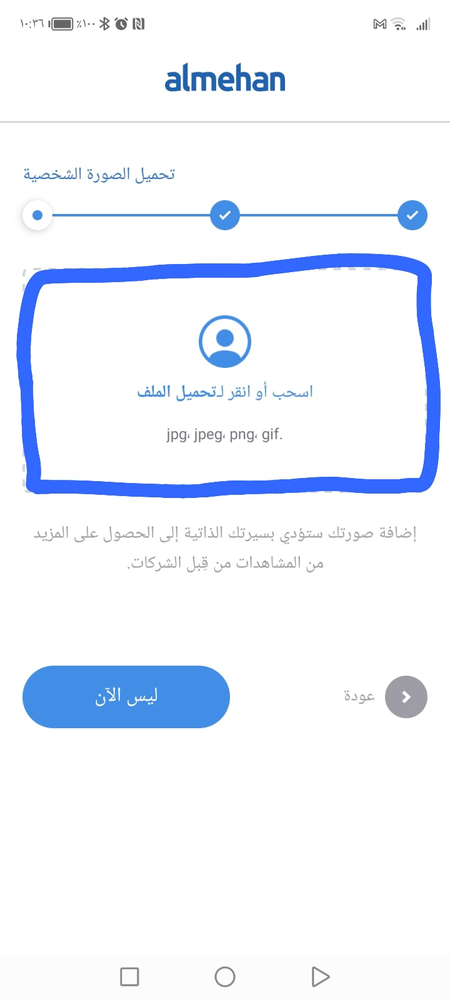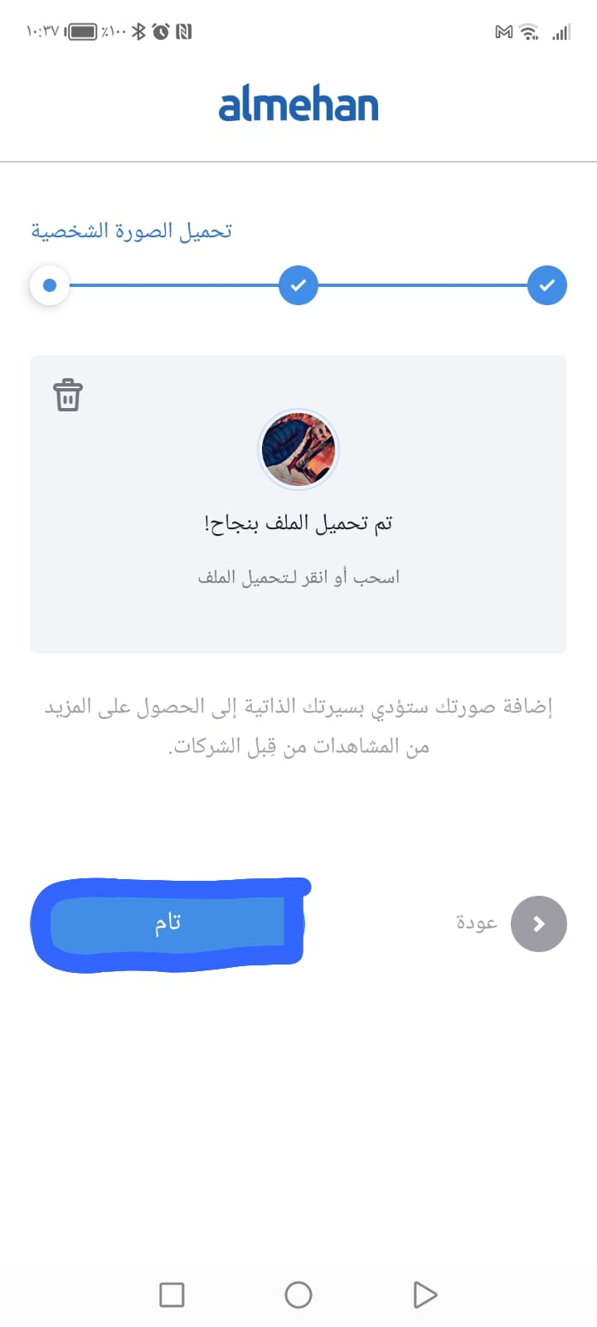

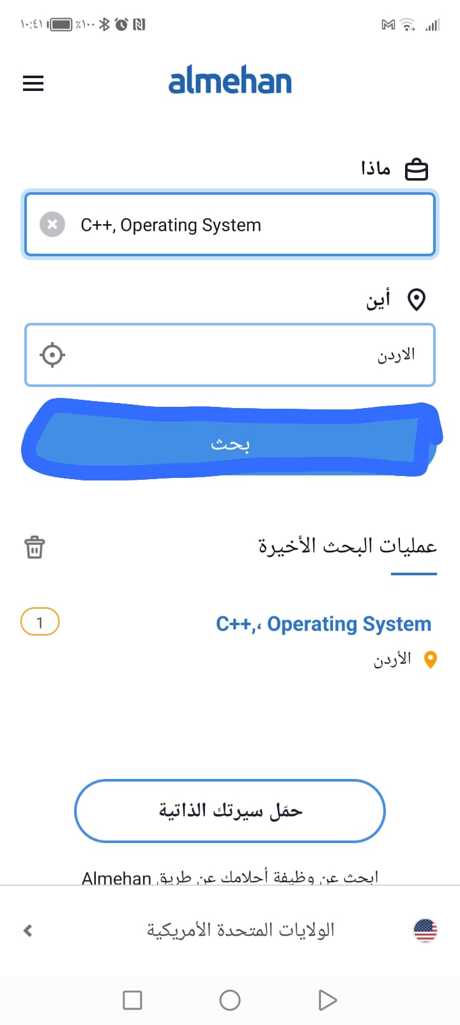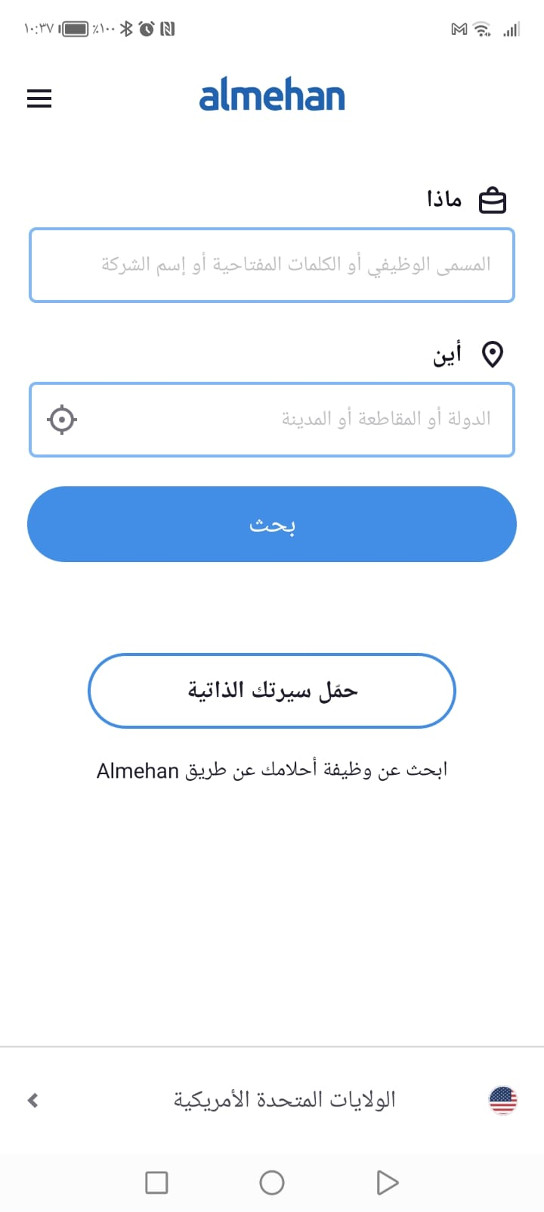

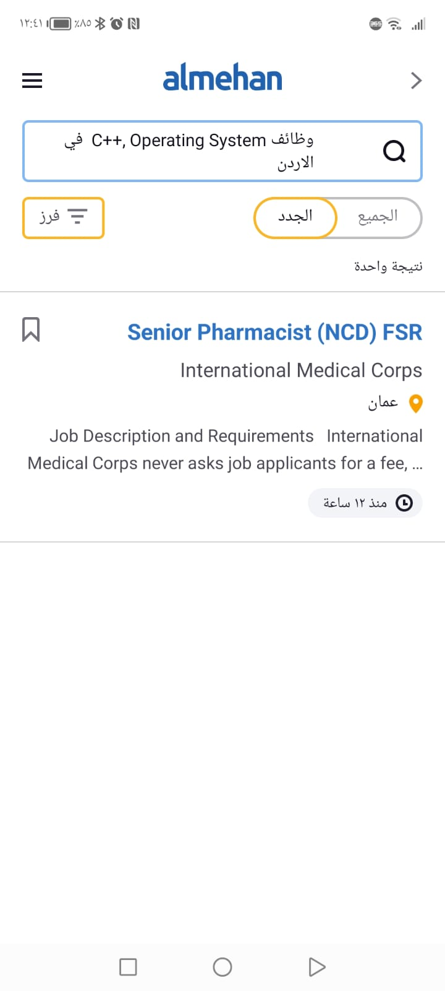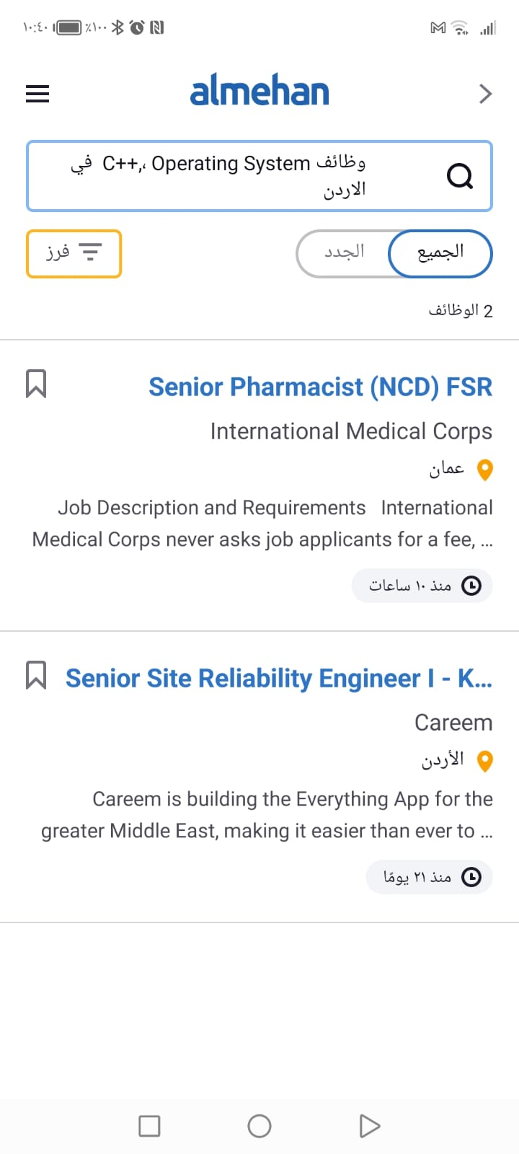

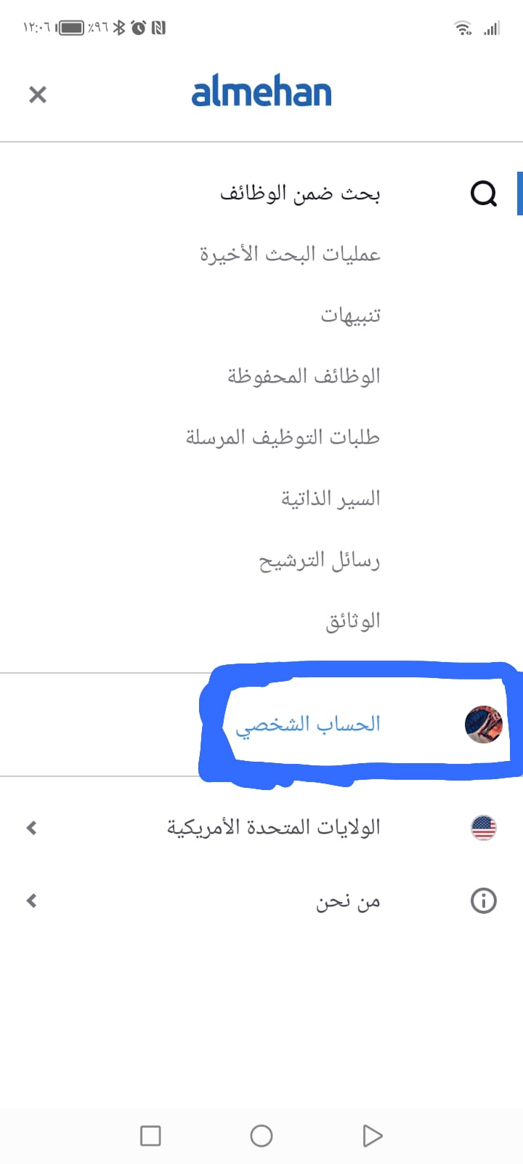



**B. the summery of project:**

The project brief provides a concise yet informative overview of the entire Employment Solutions Agency project. It summarizes the primary objectives of the project and outlines what the agency seeks to achieve. In addition, it defines the scope of the project, and defines its limits and constraints. The project summary goes into depth, identifying milestones and key dates to provide a clear perspective on the expected duration of the project. It also addresses budgetary considerations, and defines the financial framework within which the project operates. Finally, the summary highlights important achievements, results, or milestones that have already been accomplished, showing the progress and success of the project.

**C. Installation Manual:**

The Installation Manual serves as a comprehensive guide to help users install and configure the Recruitment Solution System. It provides a detailed breakdown of hardware and software requirements, ensuring that users have all the necessary components before initiating the installation process. The manual outlines step-by-step instructions for installing the system, from initial setup to database configuration. In the event of potential issues or troubleshooting requirements, it includes a troubleshooting section to assist users in resolving common installation-related problems. This manual aims to streamline the installation process, ensuring that users can set up the system efficiently and without unnecessary hiccups.